Grade 7 Accelerated · Unit 4 · Lessons 2–3  Multiplying and Dividing in Scientific Notation  Question Bank - Additional 4.02 | Name______________________  Date______________________  Period____________________

Show your work. Circle your final answer.
For questions 1 through 6, multiply or divide. Write each answer in scientific notation.
1. 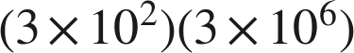

2. 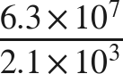

3. 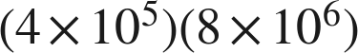

4. 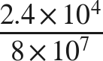

5. 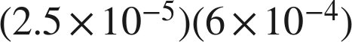

6. 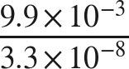

Real quantities.
7. The Amazon River discharges about  gallons of water every second.
a. About how many gallons does it discharge in one hour, which is  seconds?

b. A second river discharges about  gallons per second. How many times larger is the Amazon's rate?

8. A factory produces about 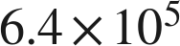 bottles per day.
a. How many bottles does it produce in 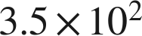 days?

b. A second factory produced  bottles in 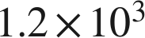 days. How many bottles per day is that?

Working backwards.
9. Find the missing number in each equation.
a.

b. 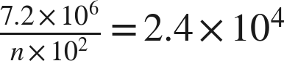

c. 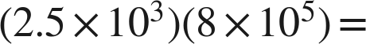 ______

Reading someone else's work.
10. Dana divides 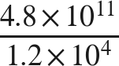 and writes . Name her mistake and give the correct quotient.

11. Which is the value of 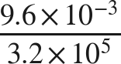 ?
○ A. 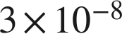
○ B. 
○ C. 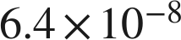
○ D. 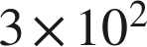

12. Select ALL of the expressions whose value is 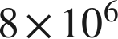.
□ A. 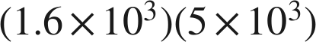
□ B. 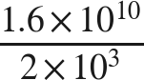
□ C. 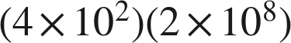
□ D. 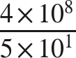
□ E. 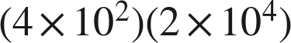
□ F. 